Why is the absence of disease not enough to bring us well-being???

Think of disease or illness as golf balls in a jar.
You seek treatment and eventually the golf balls are removed. Whether treatment is medication, surgery, counselling, exercise etc., they only serve to remove the golf balls.
What are you left with?
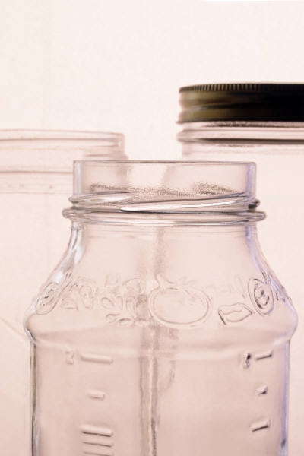
An empty jar.
The empty vessel does not bring you well-being.
You now need to re-fill the jar with key elements to achieve well-being.
According to Martin Seligman, those key elements are:
- Positive emotion
- Engagement
- Positive relationships
- Meaning/purpose
- Positive accomplishment
So, if you are sitting about and feeling empty, perhaps you need to re-examine whether you remembered to fill your jar…..

